Create a script in IQ-Core to configure IPSEC for your Student Router DMVPN with the Uplink Node:

1. Verify that you have connectivity with your Student Router from IQ-Core.
2. Go to the Devices tab on the top left of the IQ-Core menu.
3. Highlight the Student Router under the list of Devices.

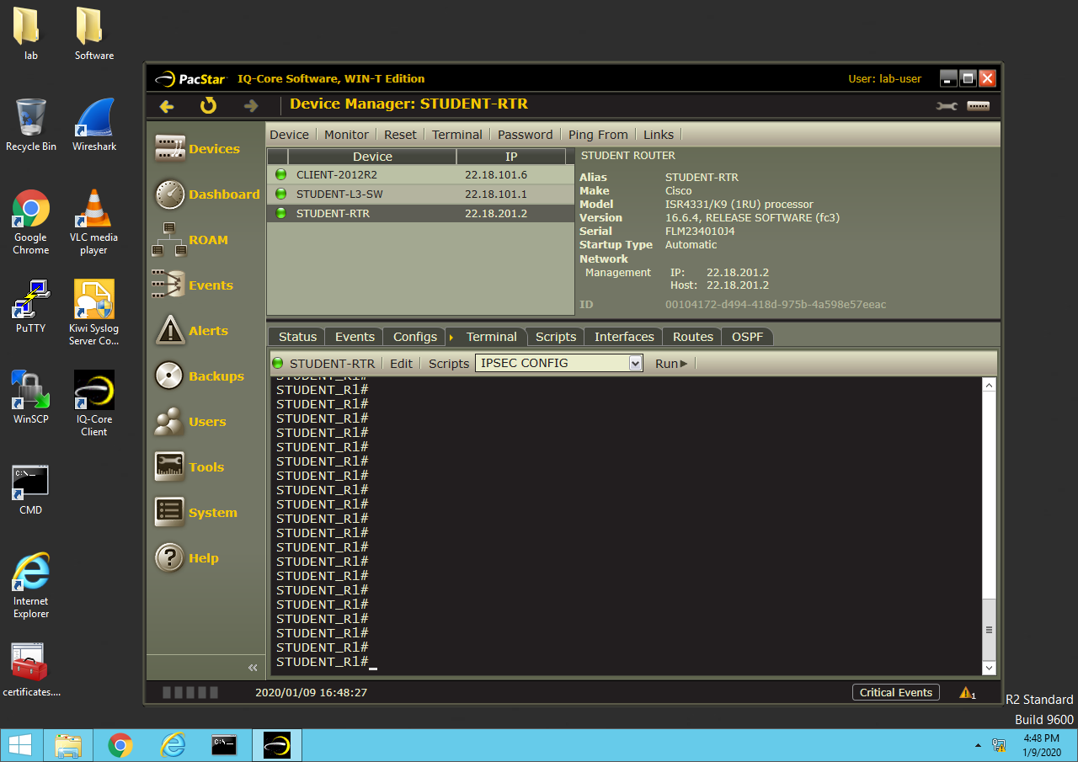

1. Click on the “Scripts” tab.
2. Click Add.

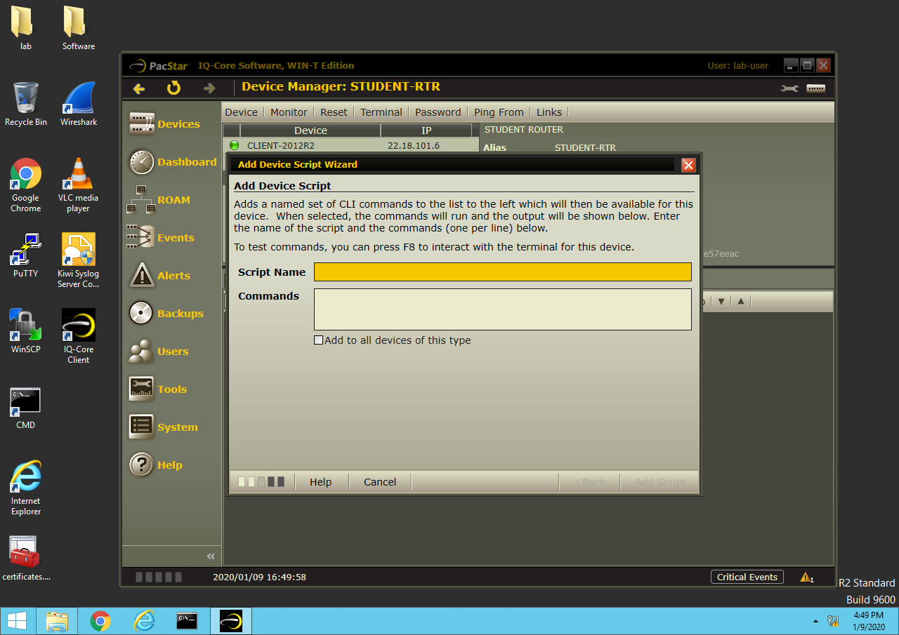

1. Input a name for the script, such as “IPSEC Configuration”
2. Enter the commands, one per line, as if you were logged in under privilege exec mode (start with “config t” )
3. Create an isakmp policy, transform set and ipsec profile using the DIV IPSEC cut-sheet in the PE-3 resource folder.
4. End your script with the command ‘do show run | begin crypto isakmp’
5. Click on the Run> button
6. If the script runs correctly, you should see the output of your “do show run… command”

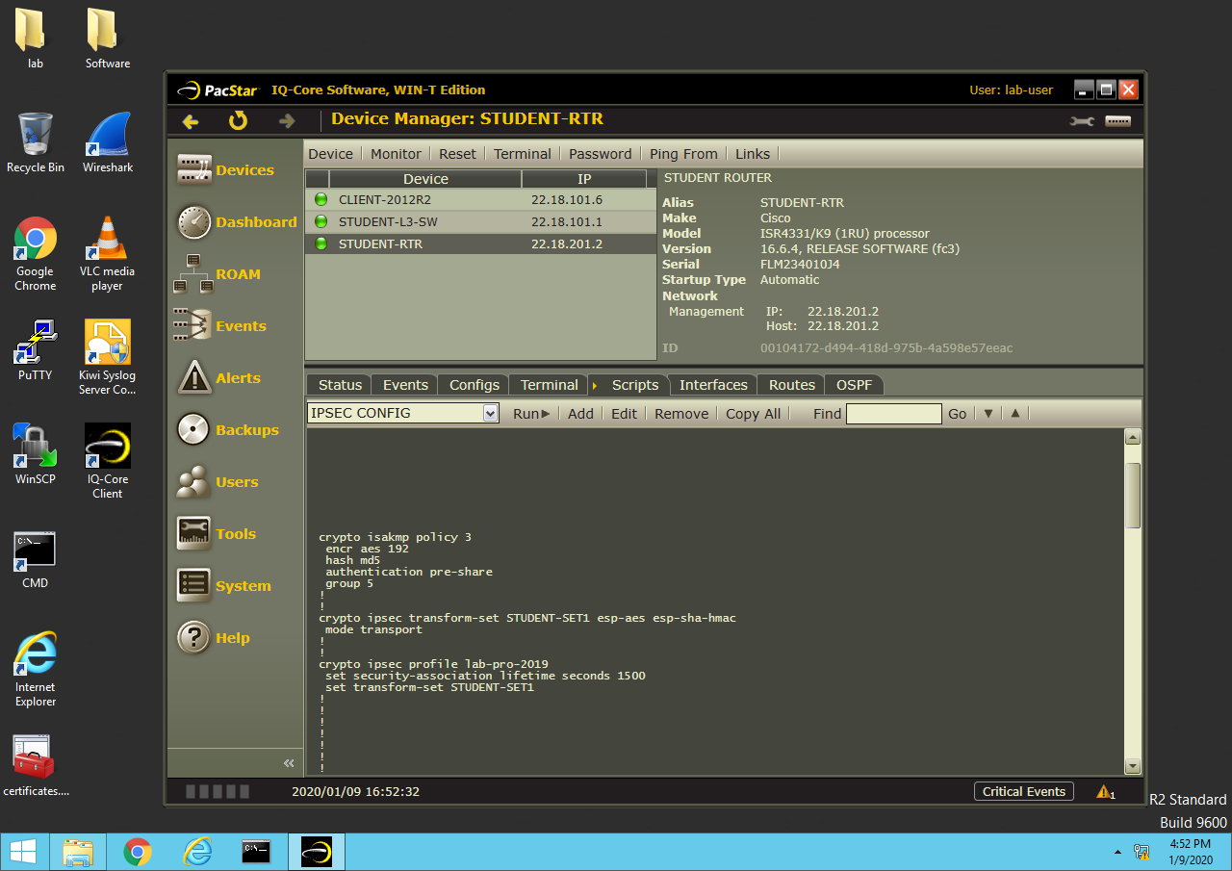

1. You can also go to the terminal tab and check the running configuration in real-time by running the same

“show run | begin crypto isakmp policy” command:

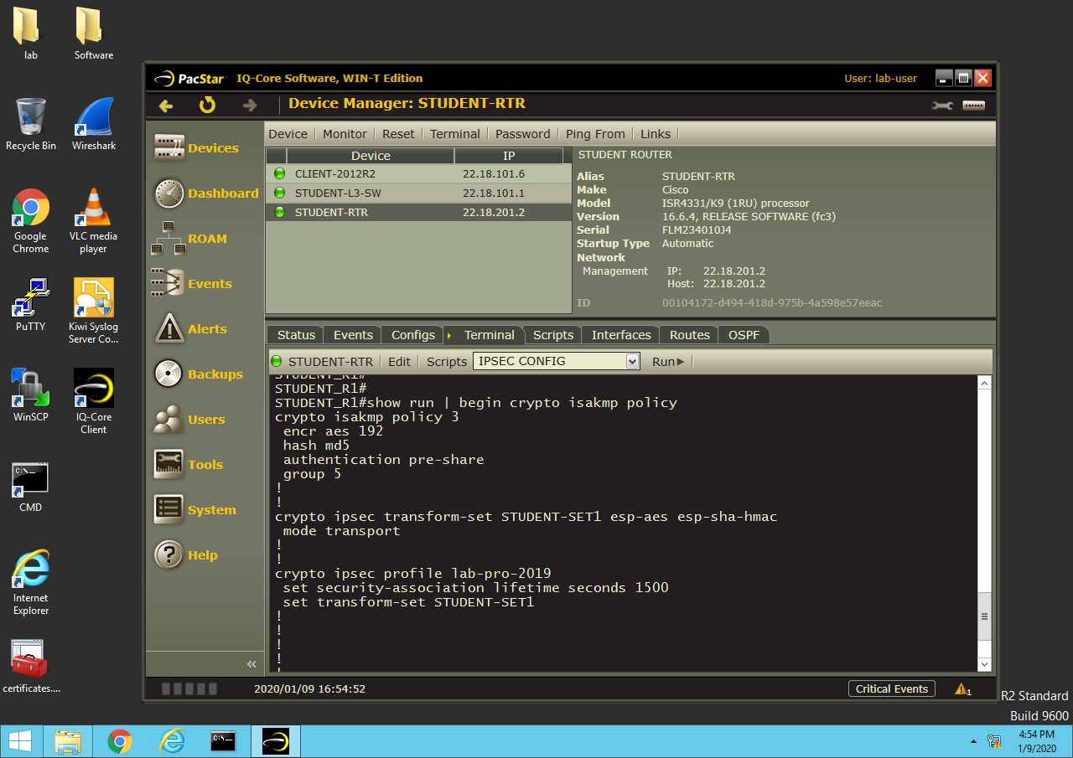

_________________________________________________________________________________________________

SCRIPT EXAMPLE:

**This is just an example for IQ-Core script input, do not paste this configuration into your student router**

Conf t

Crypto isakmp policy 6

Hash sha

Encryption aes 128

Group 2

Authentication pre-share

Exit

Crypto ipsec transform-set TEST-SET esp-aes esp-md5-hmac

Mode transport

Exit

Crypto ipsec profile ZACH

Set transform-set TEST-SET

Set security-association lifetime seconds 1800

Do show run | begin crypto isakmp